### Knowledge Checks

# LAB 1

Question 1

1/1 point (graded)

When you connect to an Access database, which entities are shown in the Navigator window?

Users from the Access database

Tables from the Access database correct

Rows in from Access database

Columns from the Access database

Question 2

1/1 point (graded)

Which three statements describe the Applied Steps area in the Query Editor window?

It records the list of steps from connecting to the data source to all the steps applied to the data.

The recorded list is based on the step that has least effect to the the step that has the most effect to the data source.

The recorded list follows the sequence of steps applied to the data source.

You can modify the connection to the data source by modifying the Source step settings.

correct

Question 3

1/1 point (graded)

Which three transformations are available when you right-click a column header in the Query Editor window?

Remove

Change Type

Duplicate Column

Count Rows

correct

Question 4

1/1 point (graded)

When using the “Split Column by Delimited” transformation, which option may result in more than two new columns?

At the left-most delimiter

At the right-most delimiter

At each occurrence of the delimiter correct

None of the above

Question 5

1/1 point (graded)

Which three views are available in Power BI Desktop?

Dashboard

Report

Data

Relationships

correct

Question 6

1/1 point (graded)

You have four queries named Query 1, Query 2, Query 3, and Query 4 in the Power BI desktop. You are creating Query 5, which will be appended at the end of Query 3.

When you load the data, which queries will be refreshed?

Query 1 to Query 4

Query 1 to Query 5

Query 3 and Query 5 correct

Only Query 5

Question 7

1/1 point (graded)

Consider the following custom column formula:

**= if [Country] = “USA” then “United States” else [Country]**

Which of the following statements describes the value of the custom column formula?

The value will be “USA”.

The value will be “United States”.

The value will be the same as the Country column.

The value will either be “United States” or whatever the value of the Country column is. correct

Question 8

1/1 point (graded)

Which transformation option converts rows as columns and columns as rows?

Transpose correct

Pivot Column

Unpivot Columns

Unpivot Other Columns

## LAB 2

Question 1

1 point possible (graded)

Which of the following cardinalities are available in Power BI table relationships?

Many to one.

One to one.

One to many.

Many to many.

All of the above.

Question 2

1/1 point (graded)

Which two cross filter directions are available in Power BI table relationships?

Single

Double

Both

Multiple

correct

Question 3

1/1 point (graded)

Consider the following DAX formula for a calculated column in the Sales table:

**UnitPrice = Sales[Revenue] / Sales[Units]**

Which three statements describe the DAX formula?

The formula creates a calculated column named UnitPrice.

The value of the calculated column is dependent on the Revenue column.

The value of the calculated column is dependent on the Units column.

The Data type of the calculated column is Text.

correct

Question 4

1/1 point (graded)

Which three options allow you to hide a field from the Report view in Power BI Desktop?

In Power BI Desktop Report view, right-click the field on the Fields list, and click Delete.

In Power BI Desktop Data view, right-click the column header on the respective table, and click Hide in Report View.

In Power BI Desktop Relationships view, right-click the field on the respective table, and click Hide in Report View.

In Power BI Desktop Report view, right-click the field on the Fields list, and click Hide.

correct

Question 5

1/1 point (graded)

In Power BI Desktop Report view, which three options will create a measure in the Sales table?

Select the Sales table in the Fields list, and then click New Measure in the Modelling ribbon.

Create the measure from any table, and then set the Home Table properties to Sales.

On the Fields list, click the ellipsis next to the Sales table or right-click any field in the Sales table, and then click New Measure.

Click New Measure, and then type in the formula Home Table = Sales.

correct

Question 6

1/1 point (graded)

What are the three reasons for which you might use calculated tables?

To union tables

To improve the speed and performance of an existing table

To perform different types of merge join

To create a table based on the result of a function or formula

## Lab 3

Question 1

1/1 point (graded)

Which three fields are available when creating a Pie chart for visualization?

Legend

Group

Details

Values

correct

Question 2

1/1 point (graded)

Consider the following chart:

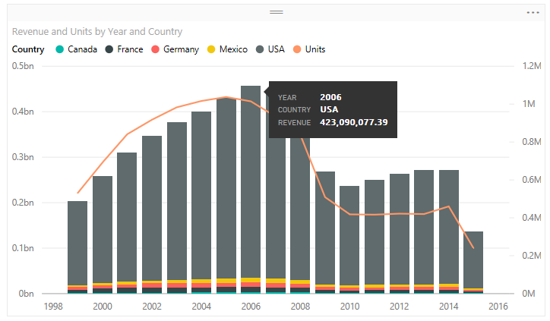

Drag and drop the fields to the corresponding settings to create the above chart.

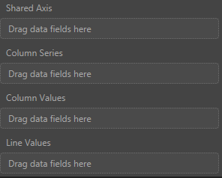

Year

Country

Revenue

Units

Category

Segment

correct

Question 3

1/1 point (graded)

By default, which level of filter behaves the same as a slicer in a report in Power BI Desktop

Visual level filter

Page level filter correct

Report level filter

Query level filter

Question 4

1/1 point (graded)

Consider the following chart:

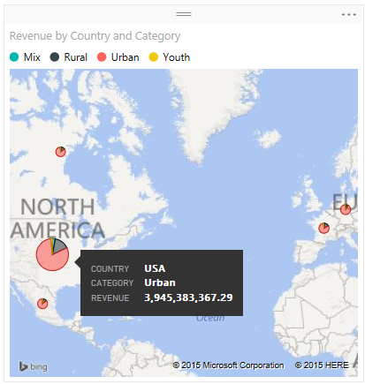

Drag and drop the fields to the corresponding settings to create the above chart.

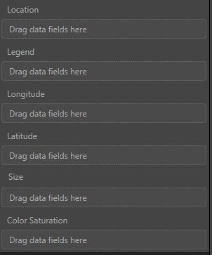

Country

Category

Revenue

Year

Segment

Units

correct

Question 5

1/1 point (graded)

Consider the following chart:

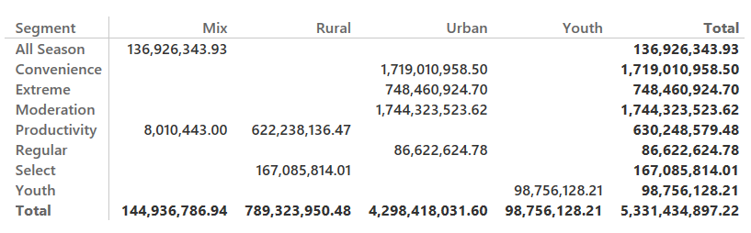

Drag and drop the fields to the corresponding settings to create the above chart.

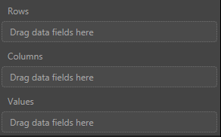

Segment

Category

Revenue

Year

Country

Units

correct

Question 6

1/1 point (graded)

When creating a waterfall chart, which two field options that you need to define?

Category

X Axis

Y Axis

Size

correct

Question 7

1/1 point (graded)

Which visualization would you use to show progress toward a particular target?

Bar chart

Scatter chart

Waterfall

Gauge correct

Question 8

1/1 point (graded)

Which of the following shapes are three of the shapes that you can create using the Insert Shapes feature in Power BI Desktop?

Flowchart

Triangle

Rectangle

Oval

correct

## Lab 4

Question 1

1/1 point (graded)

By default, where does clicking a tile on a Power BI dashboard take you?

To the latest opened report

To the report where the visual was pinned from correct

To the report that has the same data source

To the Power BI home page

Question 2

1/1 point (graded)

When you pin a visual created by the natural language query, to which dashboard is it pinned?

The last dashboard you visited

The last dashboard you created

A new dashboard

The dashboard you selected in the Pin to dashboard window correct

Question 3

1/1 point (graded)

You want to share a dashboard with your colleague. What are two possible ways to achieve this goal?

Click the ellipsis next to the dashboard name on the Dashboards list, and then click Share.

Click Share from the upper right of the dashboard you want to share.

From your browser, click Share.

Right-click anywhere in the dashboard, and then click Share.

correct

Question 4

1/1 point (graded)

You are viewing a Power BI dashboard in a browser window. What happens when you click the Focus mode of a tile?

The tile you selected expands and takes the full space. correct

The report from which the tile was pinned opens.

The Power BI desktop file gets downloaded.

The Power BI desktop file opens.

Question 5

1/1 point (graded)

Which three properties of a tile can you edit in the Power BI dashboard from the Tile details window?

Title

Subtitle

Destination link

Color scheme

correct

Question 6

1/1 point (graded)

What do you need to append to the URL of a Power BI dashboard in order to open it with the navigation pane collapsed by default?

?navigationPane=false

?navigationPane=collapsed

?collapseNavigation=true correct

?collapseNavigation=collapsed

Question 7

1/1 point (graded)

You publish a report from Power BI Desktop to Power BI service. You then make changes to your local report in Power BI Desktop by adding some visualizations. When do the changes synchronize to Power BI service?

When you save the Power BI Desktop file

When you click REFRESH NOW in Power BI service

When you re-publish the Power BI Desktop report correct

When the scheduled refresh is run on Power BI service

Question 8

1/1 point (graded)

What is the purpose of Power BI Personal Gateway?

To enable publishing reports to Power BI service.

To provide a platform for easily consuming and sharing reports.

To provide quick and secure data transfer between Power BI service and on-premises data sources that support refresh. correct

To connect and shape data, build robust models, and author well-structured reports.

## Lab 5

Question 1

1/1 point (graded)

What do you need to do to prepare an Excel workbook before uploading it to Power BI?

Format all numeric data with two decimal points.

Ensure that the data is following the star schema.

Format the data as an Excel table. correct

Name the Excel worksheet appropriately.

Question 2

1/1 point (graded)

What happens when you upload an Excel workbook that has a Power View report to Power BI?

The Excel Power View report will be converted to a Power BI report. correct

The Excel Power View report will not be imported to Power BI.

The Excel Power View report will have the data model imported, but you need to create the visualizations manually.

The Excel Power View report will be imported as Power BI Dashboard.

Question 3

1/1 point (graded)

What happens when you connect to an Excel workbook that is hosted at OneDrive for Business from Power BI?

The Excel workbook will be uploaded to Power BI.

The Excel data model will be uploaded to Power BI.

The Excel Report will be created in Power BI. correct

The Excel Power View report will be converted to a Power BI report.

## Lab 6

Question 1

1/1 point (graded)

Which three options can you add as a group member?

Computer Name

Email addresses

Security groups

Distribution Lists

correct

Question 2

1/1 point (graded)

Which two options you can give access to a content pack?

Power BI User

Power BI Group

Entire Organizations

External Organizations

correct

Show Answer

Question 3

1/1 point (graded)

Which two of the following happen when you personalize a content pack?

A copy of a content pack where you can make changes is created.

The published version of the content pack is updated.

The published version of the content pack is disconnected from the personalized content pack.

The published version of the content pack is customized.

correct

Question 4

1/1 point (graded)

When can you update a published content pack?

When the content pack is un-published

When no one has used the content pack

During the refresh period of the content pack

Anytime after you made changes to the published content pack correct

Question 5

1/1 point (graded)

You create a Power BI report using Power BI desktop and save the report as .pbix file. You upload the file to OneDrive for Business. Using Power BI service, you connect to the file hosted on OneDrive for Business. What happens when you update the .pbix file on OneDrive for Business?

The corresponding report in Power BI service also gets updated automatically. correct

The corresponding report in Power BI service needs to be refreshed manually.

The corresponding report in Power BI service does not get updated. You need to reconnect to the file hosted at OneDrive for Business.

The corresponding report in Power BI service gets deleted.

Question 6

1/1 point (graded)

What are the two privacy levels you can assigned to a group?

Public

Internal

External

Private

correct

## Lab 7

**Knowledge Checks**

 Bookmark this page

Question 1

1/1 point (graded)

Which three data sources allow you to use direct connection from Power BI?

Azure SQL Database

Azure SQL Data Warehouse

Microsoft Access

SQL Server Analysis Services

correct

Question 2

1/1 point (graded)

When you connect to a model in SQL Server Analysis Service, what is shown in the Navigator window?

List of tables in the model

List of tables and columns in the model

List of tables, columns, and fields in the model

Summary showing the available dimensions and measures correct

## Lab 8

Question 1

1/1 point (graded)

Which programming language you would use to create custom visuals?

C#

Java

TypeScript correct

Python

Question 2

1/1 point (graded)

What is the extension of a Power BI custom visual file, downloaded from the Power BI visuals gallery?

.pbix

.pbivis

.pbiv

.pbiviz correct